**Exp. 1** **Design an LED flasher**

**Circuit Diagram**:

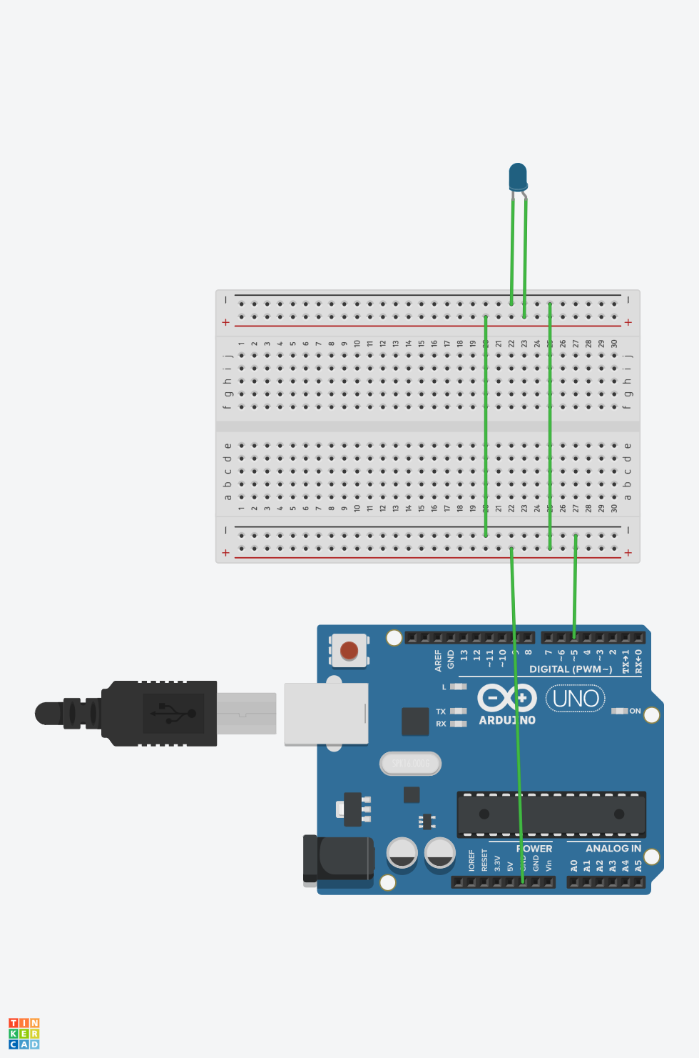

**Theory:**

Concepts Used:

1. Introduction to Arduino.
2. Using of LED.
3. Coding Arduino.
4. Working with breadboard.

**Learning & Observations**:

Learned the use of breadboard.Understood the use of LED. Understood the working of Arduino.

There are many uses of Arduino in electronic field . We can make many useful devices like drones using Arduino.

**Problems & Troubleshooting**

Unknowingly the negative terminal of LED is connected to the digital output of Arduino.

Understood the mistake and learned the positive and negative terminals of LED and positive terminal connected to the digital output and negative terminal connected to the ground.

**Precautions**

1. Check the LED and Arduino are working properly.
2. Declare pins used .
3. Declare pin to which the positive terminal of LED is connected.
4. Connect positive terminal of elements to the digital output and negative terminal to the ground.

**Learning Outcomes**

Learned Arduino coding and it was really fun.Understood the uses of Arduino . Things I learned will be very useful.

Learned the use of breadboard and LED.